**HEC1Rmodel: EC2**

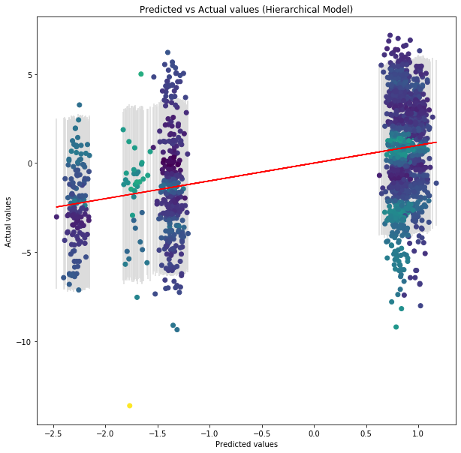

**HEC2Rmodel: EC2 + EC3**

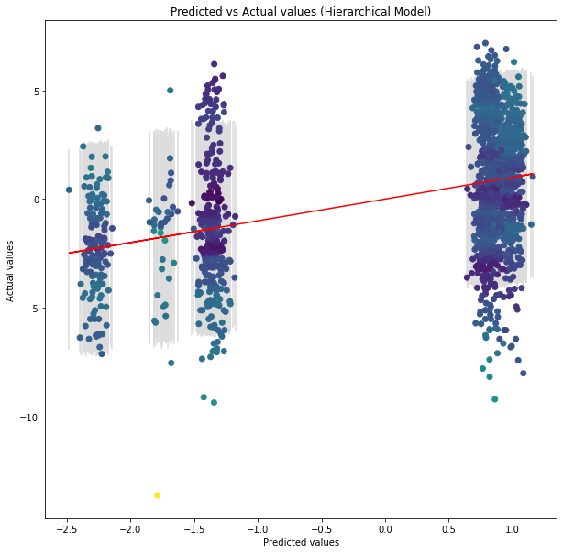

**HEC3model: EC2 + EC3 + EC4**

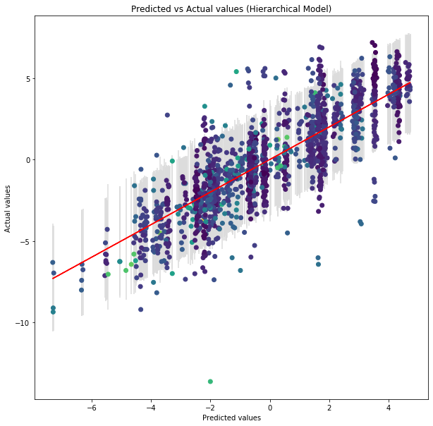

**HO1skmodel: SUPERKINGDOM**

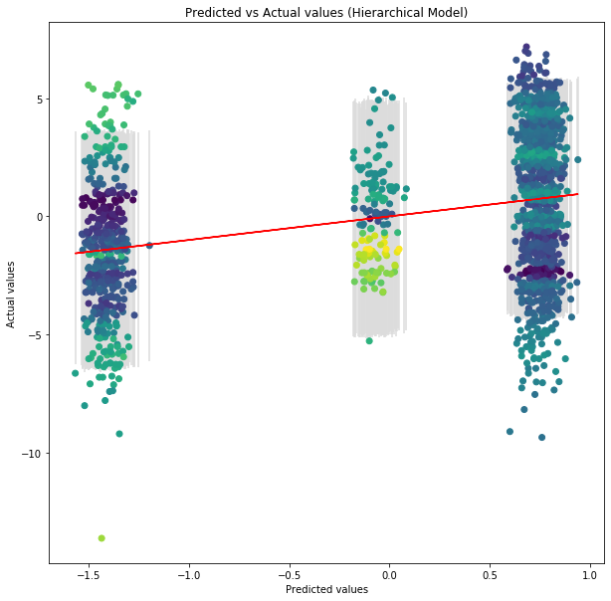

**HO2skmodel: SUPERKINGDOM + FAMILY**

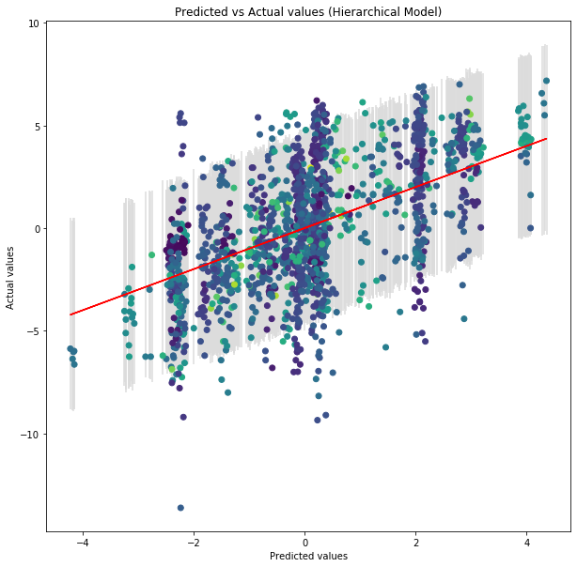

**HO3skmodel: SUPERKINGDOM + FAMILY + GENUS**

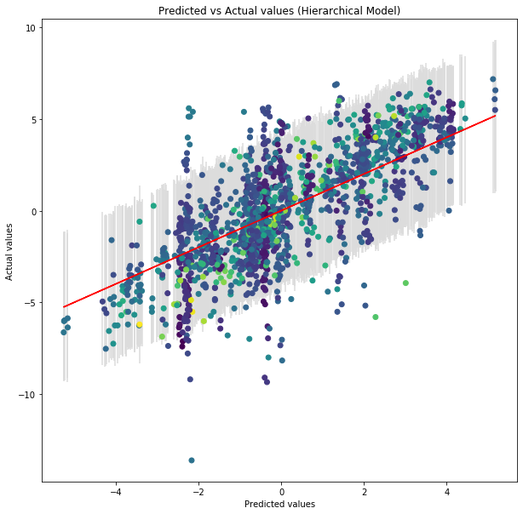

**HO4skmodel: SUPERKINGDOM + FAMILY + GENUS + SPECIES**

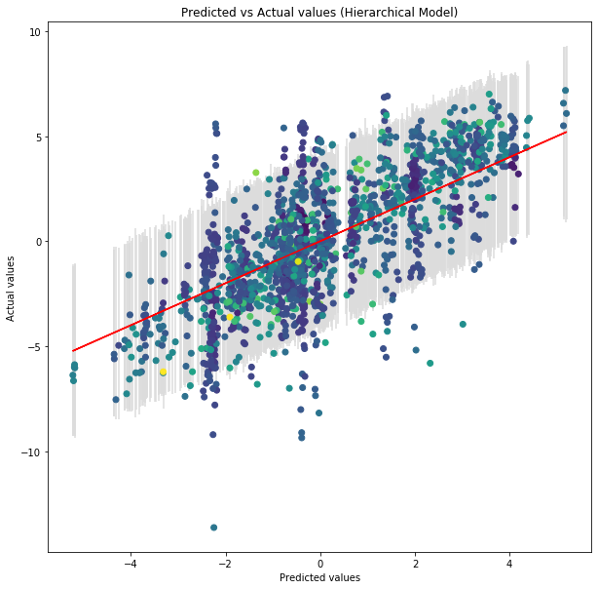

**HO4model: SPECIES**

